7

Analyses of Components with Mixed Elements

Exercise 1

* Make a copy of the Chapter’s case study 2 simulation file:



* After the study has been copied, edit the three **Local Interaction** definitions.
  + For instance, the step to edit the first interaction is shown below:



* Within the **Local Interactions** property manager that appears, change the interaction type to **Bonded** as follows:



* After completing the above change, the items under the **Connections** folder should appear as shown below:

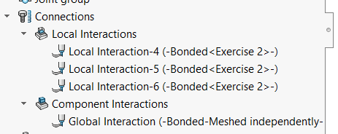

* With the above steps completed, re-mesh the components, then run the analysis to complete the simulation study
* You will notice that the simulation runs faster compared to the previous interaction definition (a matter of a few seconds)
* You will also notice that the deflection of the structure along with the Y-axis has changed (it becomes underestimated)

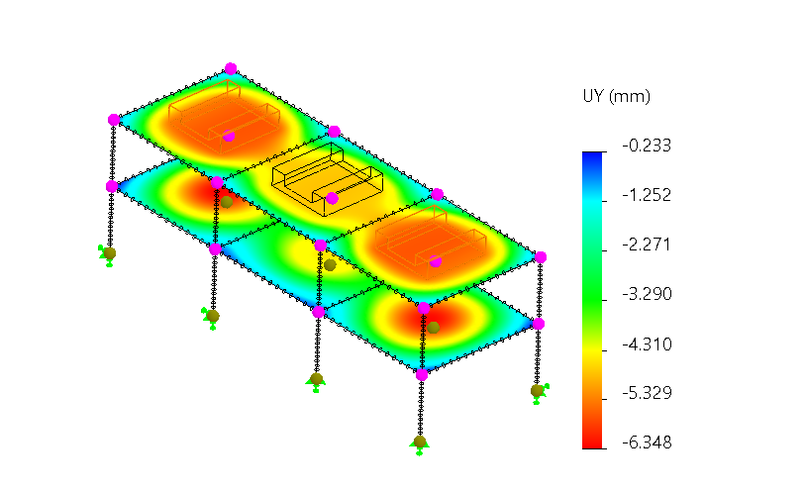

* The bending stress of the beams and columns along direction 1 do not change much:

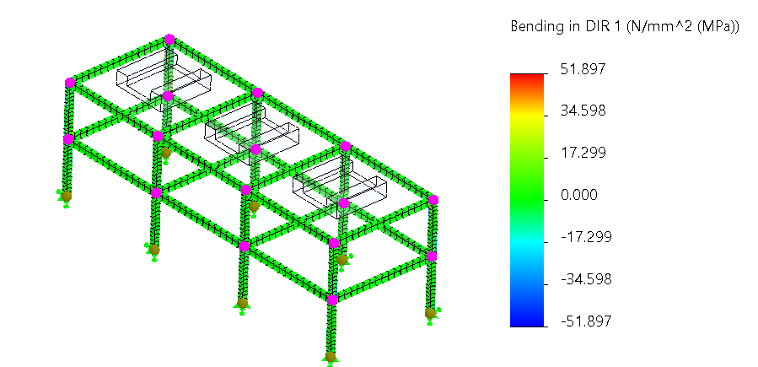

* The bending stress of the beams and columns along direction 2 show a noticeable reduction compared to when we used the **contact local interaction**:

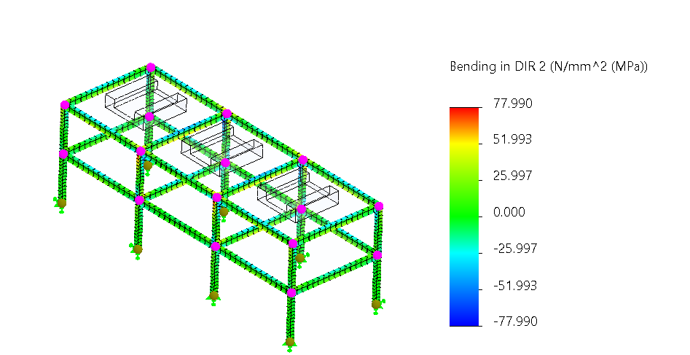

Exercise 2

* Make a copy of the Chapter’s case study 2 simulation file.
* Make changes to the thickness of the slabs.
  + For instance, the steps for updating the thickness of the top slabs are shown below:





* + Change the thickness of the bottom slabs to 100 mm.
* Update the Study’s property options to disable the “*Use soft Spring to stabilize the model*” as shown below:



* Remesh the components, run the analysis to complete the simulation study and analyze the results accordingly.